RENTAL AGREEMENT

This Rental Agreement is made and executed on this the 11th day of January 2023 at Hyderabad, by and between:

1. Sri D.Keerthi Vardhan Raju S/O Vishnu Vardhan Raju, aged about 32 years, Occupation: Business , R/o. H.N. plot.39, lecturers colony, hayathnagar, Hyderabad-501 505.

(Hereinafter called the “LESSORS/OWNERS", which expression shall mean and include all their legal heirs, successors, assignees, administrators, and agents etc.,)

AND

* 1. SRI.Arghya Mazumdar S/o. Subrata Kumar Mazumdar aged about 26 years, Occupation: Software employee, R/o. BC- 32, Salt Lake City, Sector 1 Bidhannagar (m), North 24 Parganas, West Bengal 700064.
  2. Sri.Gundu Koushik S/o Gundu Karunakar, Aged 27 R/o 15-6-103, Papaiah Pet Chaman, Warangal, Telangana - 506002.
  3. 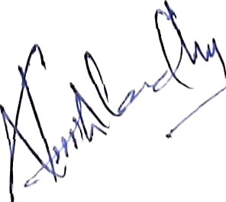Sri.Somesh Vijayrao Deshmukh, S/o Vijayrao Deshmukh, Aged.29, R/o Deshmukh Galli, Zari, Parbhani, Maharashtra, 43150.

:: 2 ::

(Hereinafter called the “LESSEE/TENANT”, which expression shall mean and include all his legal heirs, successors, assignees, administrators, and agents etc.)

WHEREAS the LESSORS are the absolute owners and possessors of Flat No. 814 of 8th floor, of “S.M.R Symphony Apartments, SITUATED AT G ACHIBOWL I, HYDERABAD District, TELANGANA , having

purchased the same by SRI. KEERTHI VARDHAN RAJU.D hereinafter called the schedule property.

WHEREAS the LESSEE have approached the LESSORS seeking the schedule premises for rent to carry on Services of REAL ESTATE, CONSTRUCTION, MEETINGS. After due negotiations the Lessors have agreed to let out the schedule property on monthly rent of Rs,60,000/- (Rupees SIXTY Thousand only) per month. In pursuance of the above acceptance by both the parties. The parties have entered into an agreement on the following terms and conditions stipulated hereunder.

NOW THIS RENTAL AGREEMENT WITNESSETH AS FOLLOWS:-

# That the Lessee shall pay the monthly rent of Rs.28,050/- (Rupees Twenty eight Thousand fifty rupees only) per month which shall be paid on or before 5’^ of every calendar month.

1. The hike of 10% will affect from March 1, 2022, to Jan 31 2023, total rent is 28,050/- from 01.03.2022.
2. That the Lessee shall carry on the works of REAL ESTATE, CONSTRUCTION, MEETINGS in the schedule premises.
3. That the Lease is commenced from 1" day of march, 2022 and agreed period is for 11 (eleven) months.

That the Lessors and Lessee shall issue 3 months’ notice to terminate the Lease.

1. That the Lessee shall pay the Electricity Charges. The Lessors shall pay the Property Tax and charges to the concerned authorities in respect of the schedule property.
2. That the Lessors and Lessee hereby agreed that the period of Tenancy shall be extended for further period on the increase of 10% of the existing rent.
3. 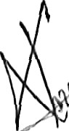The Lessee shall obtain necessary permissions, registration certificate and licenses etc., from the concerned Departments of State / Central Government and also from concerned Municipality / Panchayat/ Corporation and if they fail to obtain necessary permissions, registration Certificates ana licenses etc., he will be held responsible and liable, and the Lessor is neither responsible or liable.

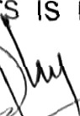

:: 3::

1. That the Lessee prohibited from doing any business which is detrimental to the interest of government and against public policy. The Lessee shall keep the premises in neat and clean condition as a man of ordinary prudence and whitewash it periodically.
2. The owner has a cabin inside the schedule office premises. The maintenance and the power bill will be paid by the owner for that particular cabin.

SCHEDULE PROPETY

All that part and parcel of the Schedule property is Flat. 814 of 8th floor, of “S.M.R Symphony Apartments, SITUATED AT GACHIBOWLI, HYDERABAD District, TELANGANA and bounded by:

NORTH :: OPEN TO SKY; SOUTH :: OPEN TO SKY; EAST :: OPEN TO SKY;

WEST :: ENTRANACE BALCONY;

IN WITNESSES whereof the Lessors and Lessee herein have signed on this Agreement of Rental with their free will and consent on this the day, month and year first above mentioned in the presence of the following witnesses.

WITNESSES:

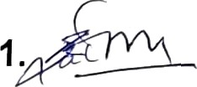

2.

SIG. OF "SSORS/OWNERS

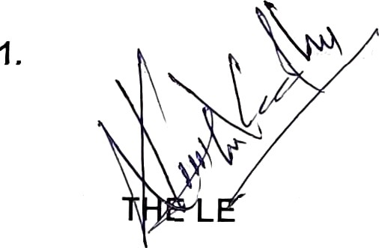SIG. OF THE LESSEE/TENANT